Yesterday I also did some research about the performance impact. We probably need to discuss how to handle this today

Test scenario: a simple update of 100 records of InventTableModule, when we don’t skip Dual Write

Impact during the update:
Update itself takes ~1ms
Pre Dual Write method – 6mm
Post Update Dual Write – 35ms
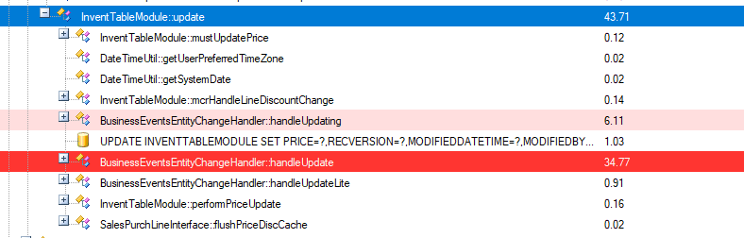

Impact during transaction commit
41 seconds delay caused by Business events processing and Dual Write processing
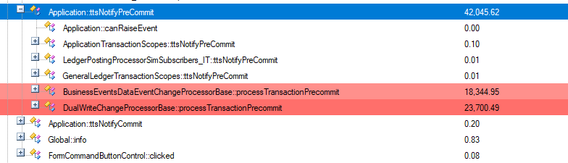

The main issue with this transaction delay is that it is happening after all post-transaction events, e.g. InventSum update

So we start seeing issues like below, where InventSum (a key table) is getting blocked.
InventSum current design assumes that the table itself is updated as a last transaction step, blocking all other sessions for a small amount of time
But if 40 seconds are added to this time, that may impact other sessions

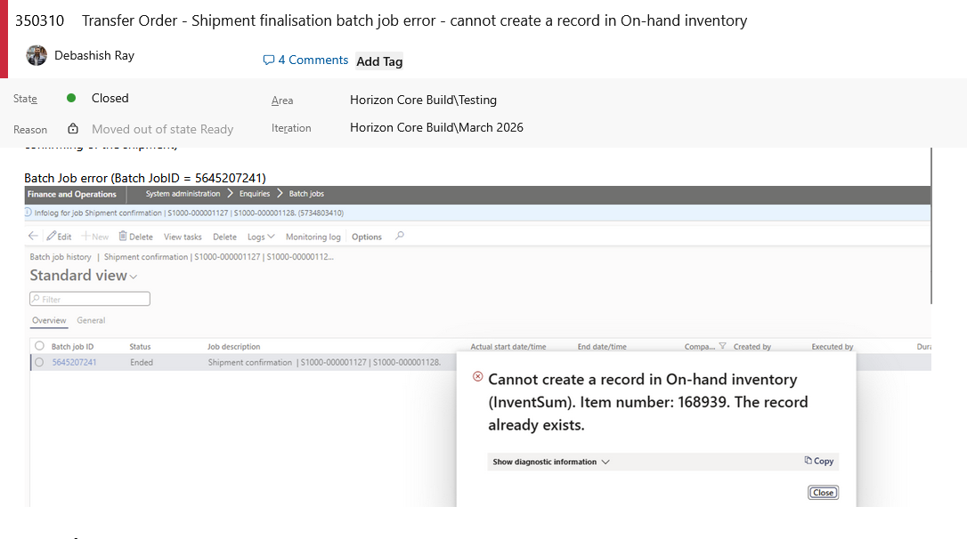

Question here:
1. Can Data events and Dual write processing be used in processes that work with on-hand/transactional data? How InventSum updates will be handled then? How we can monitor-resolve such issues like above
2. Any planned optimisation to lower the overhead caused by Data events and Dual write? Current 100 records actual update time 100ms, but processing with DW the same updates takes 80 seconds. It is the correct timing, or maybe some feature keys are not enabled/settings are wrong

Denis

